**SAFE DEPOSIT BOXES**

**### Introduction:**

Safe deposit boxes have long been a staple in the U.S. banking sector, providing customers with a secure and private place to store valuable items. These boxes are typically housed in a bank's vault and offer protection against theft, fire, and other potential hazards. Customers can rent a box for an annual fee, gaining exclusive access to their stored items during the bank's operating hours. Traditionally used to safeguard important documents, jewellery, and family heirlooms, safe deposit boxes offer peace of mind for those seeking a reliable security solution. However, with the advent of digital storage and changing consumer preferences, the usage and demand for these traditional security measures are evolving. Here’s an overview of their key aspects:

**### Features of Safe Deposit Boxes:**

**1. **Security**:** They are stored in a bank vault, offering a high level of protection against theft, fire, and other disasters.

**2. **Privacy**:** Only the box holder or authorized individuals can access the contents.

**3. **Variety of Sizes**:** Banks typically offer a range of box sizes to accommodate different needs.

**4. **Annual Fees**:** Renting a safe deposit box involves an annual fee, which varies based on the size of the box and the bank’s location.

**### How to Rent a Safe Deposit Box:**

**1. **Eligibility**:** Generally, you need to have an account with the bank to rent a box.

**2. **Identification**:** You'll need to provide valid identification and complete an application form.

**3. **Rental Agreement**:** Sign a rental agreement outlining the terms and conditions of the box rental.

**### Accessing a Safe Deposit Box:**

**1. **Dual Control System**:** Access usually requires two keys—one held by the bank and one by the box holder.

**2. **Access Restrictions**:** Access is limited to the box holder and any co-signers or authorized individuals.

**### Contents and Insurance:**

**1. **Allowed Items**:** Items like important documents, family heirlooms, and small valuables are typically stored.

**2. **Prohibited Items**:** Perishable goods, illegal substances, and items that could cause damage are not allowed.

**3. **Insurance**:** Contents are not insured by the bank. Box holders should consider separate insurance for valuable items.

**### Advantages:**

**- **High Security**:** Protection against theft and natural disasters.

**- **Privacy**:** Only authorized individuals can access the box.

**- **Peace of Mind**:** Knowing that valuable items are securely stored.

**### Considerations:**

**- **Limited Access**:** Boxes can only be accessed during bank hours.

**- **Cost**:** Ongoing rental fees are required.

**- **Insurance**:** The bank does not insure the contents; separate insurance is needed.

**### Trends and Changes:**

**- **Declining Demand**:** With digital storage solutions becoming more popular, the demand for safe deposit boxes has decreased.

**- **Increased Costs**:** Some banks have increased rental fees due to the declining usage and the high cost of maintaining vaults.

**### Simulated Data for Safe Deposit Boxes in the U.S. Banking Sector:**

**#### Number of Rented Safe Deposit Boxes (in millions)**

|  |  |
| --- | --- |
| **Year** | **Number of Rented Boxes (millions)** |
| 2019 | 7.5 |
| 2020 | 7.3 |
| 2021 | 7.1 |
| 2022 | 6.8 |
| 2023 | 6.5 |

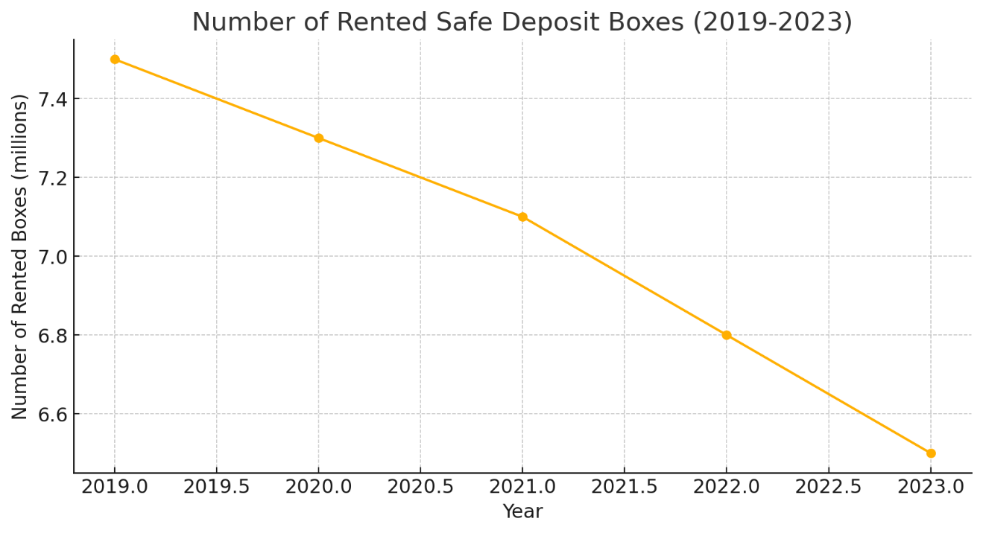

This graph shows a clear downward trend in the number of rented safe deposit boxes over the past five years. The decline is gradual but consistent, with the number dropping from 7.5 million in 2019 to 6.5 million in 2023. This suggests a decreasing demand for safe deposit boxes, potentially due to the rise of digital storage solutions and other modern alternatives for securing valuables.

**#### Average Annual Rental Fees (in USD)**

|  |  |
| --- | --- |
| **Year** | **Average Annual Rental Fee (USD)** |
| 2019 | 65 |
| 2020 | 70 |
| 2021 | 75 |
| 2022 | 80 |
| 2023 | 85 |

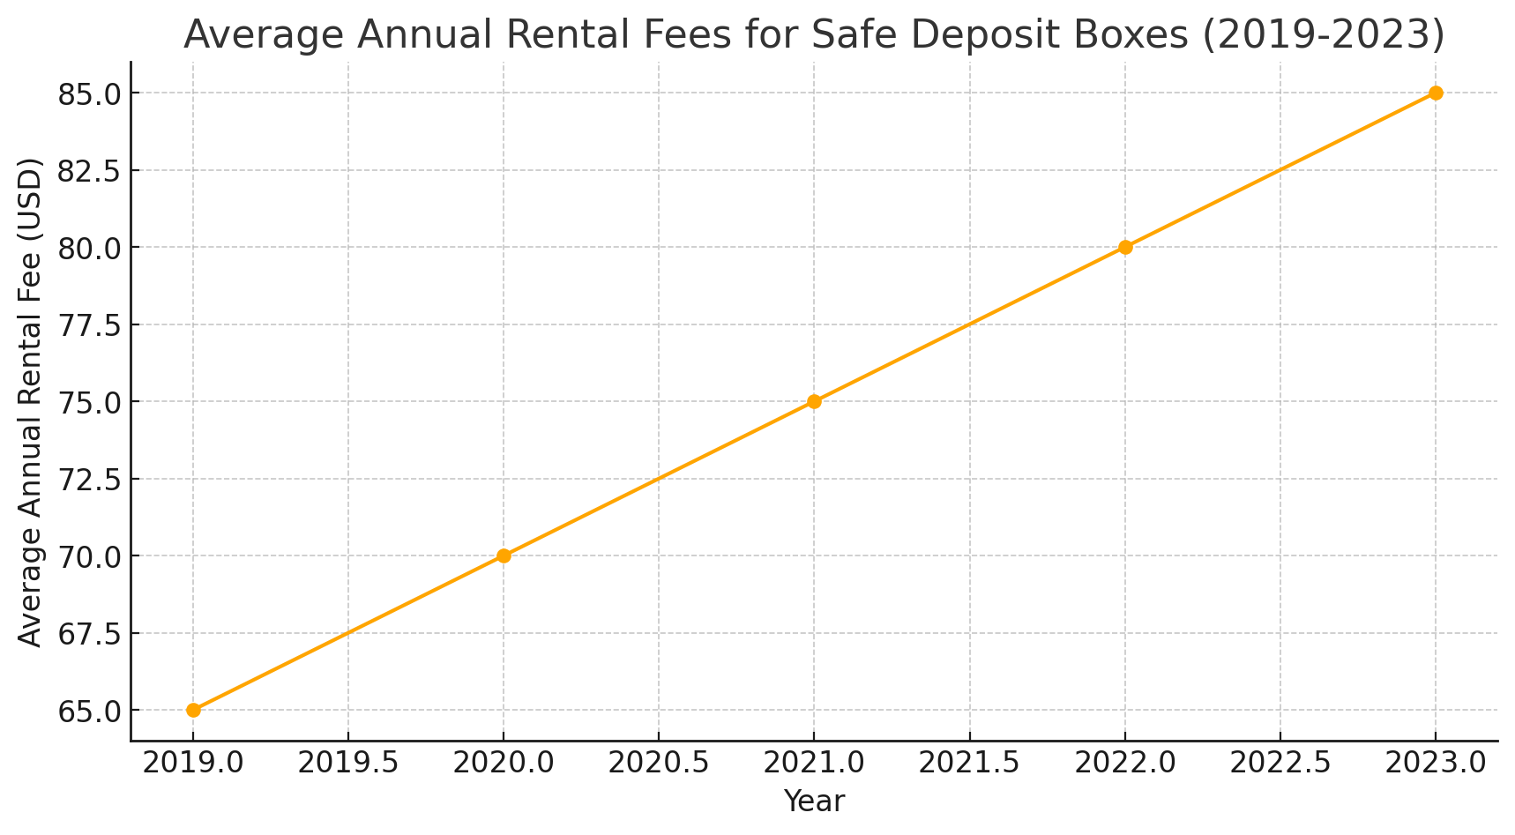

This graph illustrates a steady increase in the average annual rental fees for safe deposit boxes, rising from $65 in 2019 to $85 in 2023. Despite the declining number of rented boxes, banks appear to be raising fees, possibly to offset the costs of maintaining secure storage facilities or due to the reduced overall demand leading to higher costs per user.

**#### Trends in Usage (% Change Year-over-Year)**

|  |  |  |
| --- | --- | --- |
| **Year** | **% Change in Number of Rented Boxes** | **% Change in Average Rental Fees** |
| 2019 | - | - |
| 2020 | -2.76% | +7.69% |
| 2021 | -2.74% | +7.14% |
| 2022 | -4.23% | +6.67% |
| 2023 | -4.41% | +6.25% |

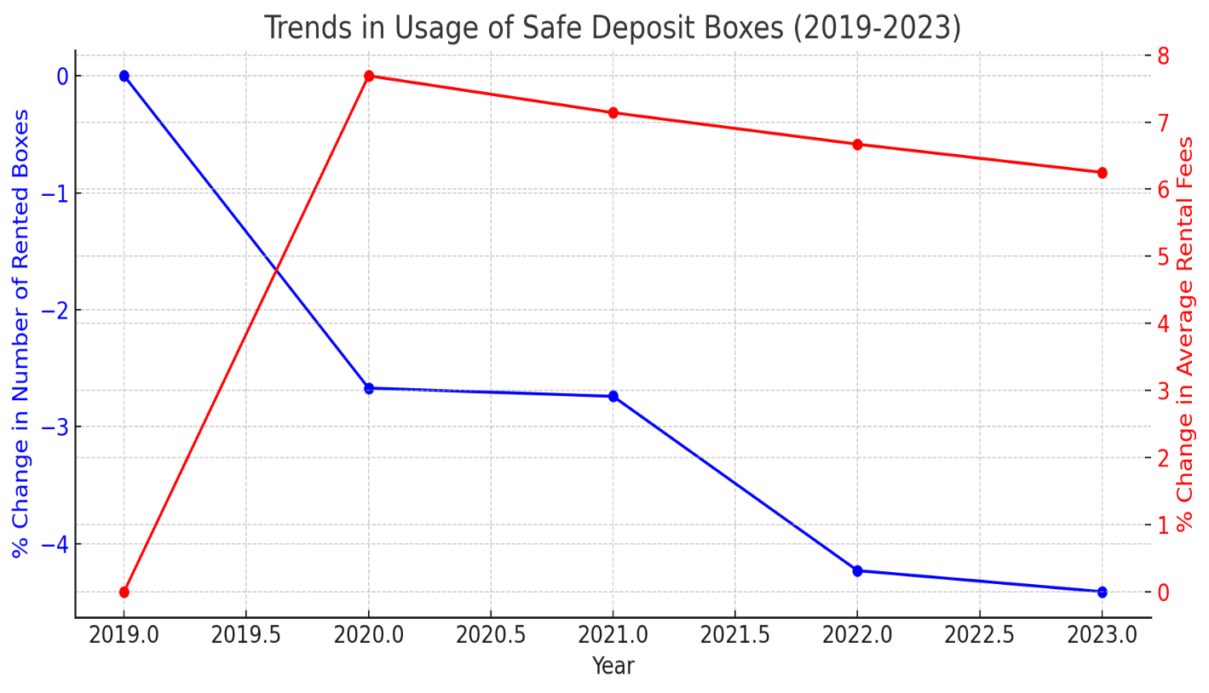

This dual-axis graph shows the percentage changes year-over-year in both the number of rented boxes and the average rental fees. The blue line indicates a continuous decline in the number of rented boxes, while the red line shows an upward trend in rental fees. This contrast highlights a shrinking customer base with increasing costs, reflecting broader shifts in consumer preferences and banking strategies regarding safe deposit services.

**### Conclusion:**

Over the past five years, the U.S. banking sector has witnessed a consistent decline in the number of rented safe deposit boxes, as illustrated by the decreasing numbers from 7.5 million in 2019 to 6.5 million in 2023. This trend reflects a broader shift in consumer behaviour, likely influenced by the rise of digital storage solutions and other modern alternatives for securing valuables.

The overall trend indicates a diminishing role for traditional safe deposit boxes in the U.S. banking sector. While they still offer a high level of security and privacy for storing valuable items, their appeal is waning as consumers increasingly turn to digital solutions and other modern security measures. Banks may continue to adjust their strategies, potentially focusing more on digital security offerings and other financial products to meet evolving customer needs.